Lab 6 report
Trần Quốc Nam – ITITIU21250
Table of content
- Database and user model
- User model and DAO
- Login/Logout controller
- Views and Dashboard
- Explanation and result

- Database and user model
  - Create user table
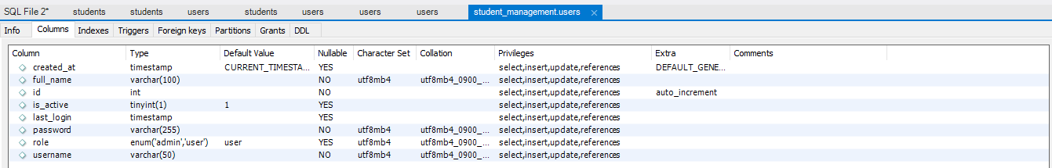
User table with attributes :
- id INT PRIMARY KEY AUTO_INCREMENT,
- username VARCHAR(50) UNIQUE NOT NULL,
- password VARCHAR(255) NOT NULL,
- full_name VARCHAR(100) NOT NULL,
- role ENUM('admin', 'user') DEFAULT 'user',
- is_active BOOLEAN DEFAULT TRUE,
- created_at TIMESTAMP DEFAULT CURRENT_TIMESTAMP,
- last_login TIMESTAMP NULL

  - Generate Hashed passwords
Import jbcrypt library to implement Hashing for password
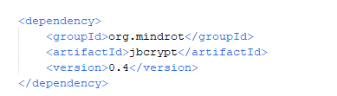

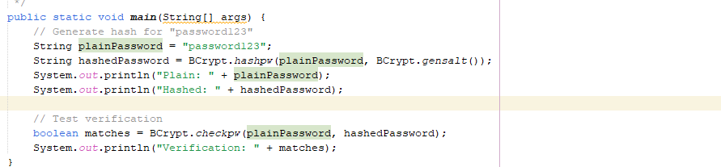
  - Insert Test Users
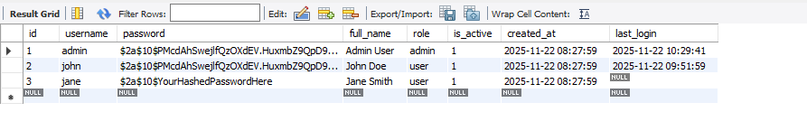
  - Checkpoint #1

- User Model and DAO
  - Create User model
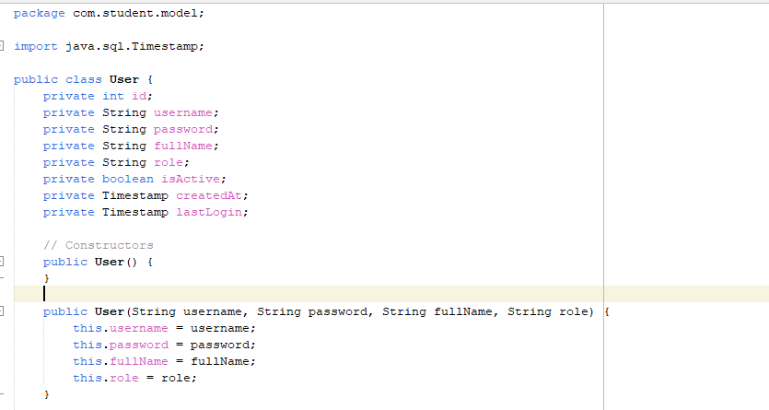

  - Create UserDAO
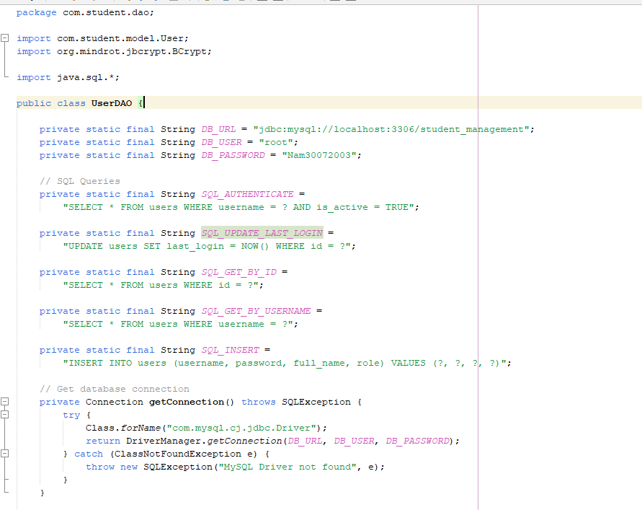
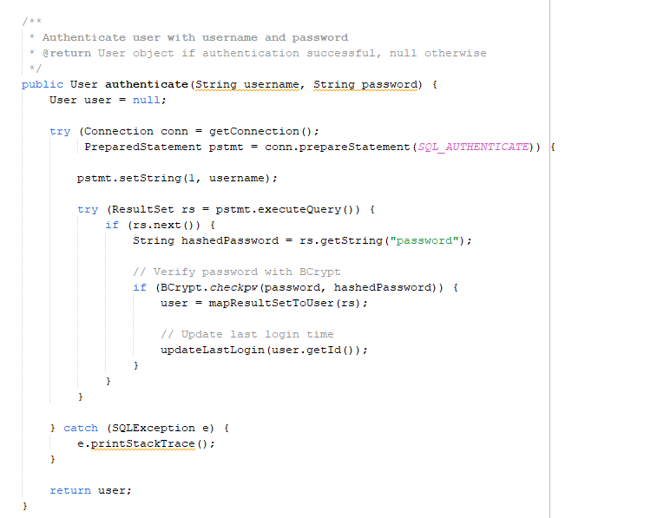
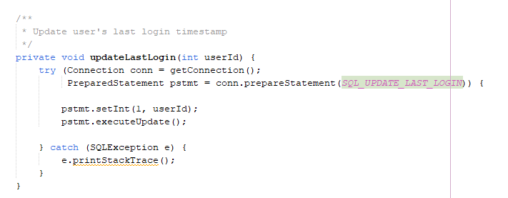
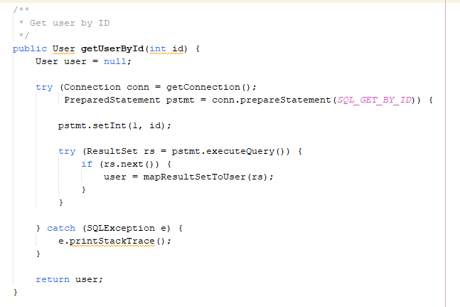
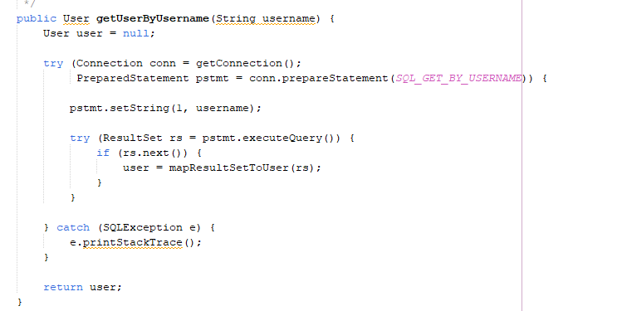
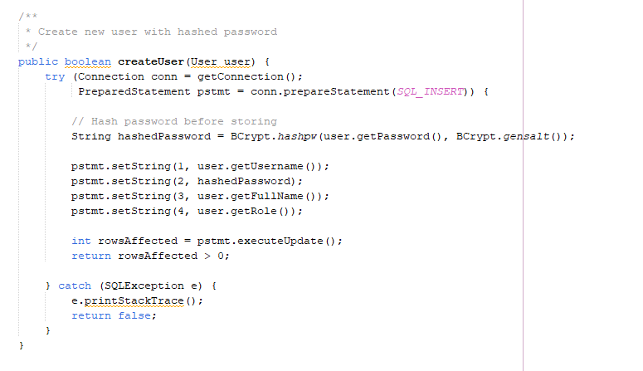
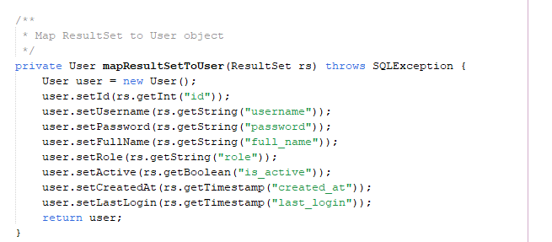

- Login/Logout Controllers
  - Create Login Controller

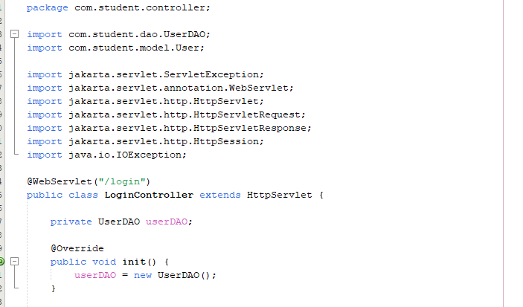
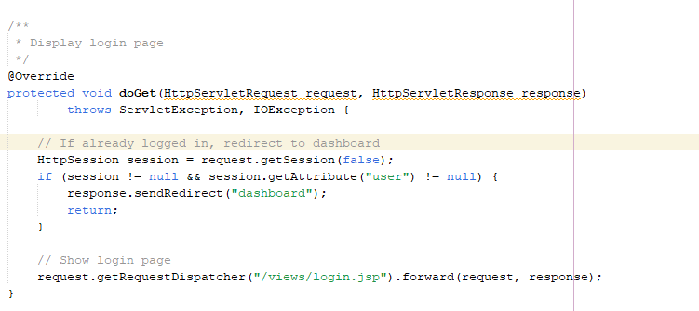
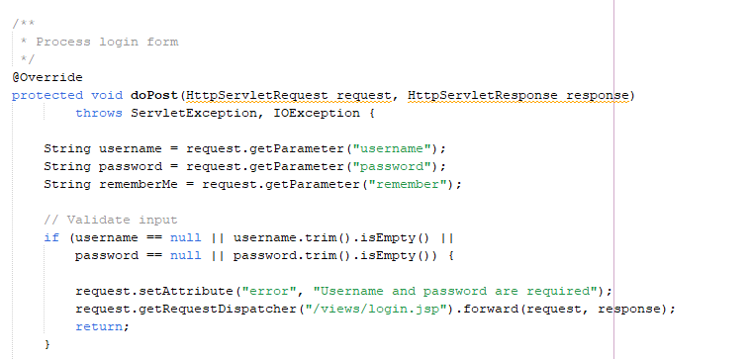
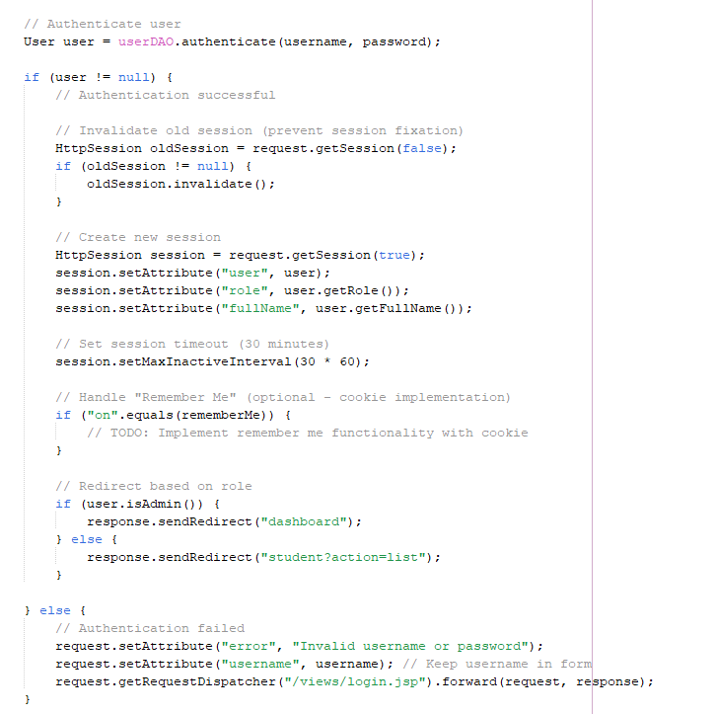
  - Create Logout Controller
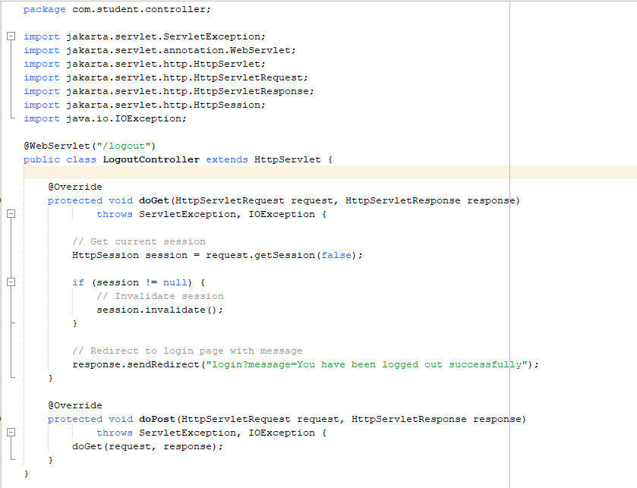

- Views and Dashboard
  - Create Login View
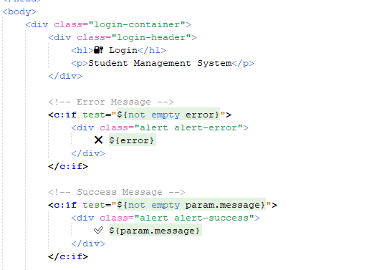
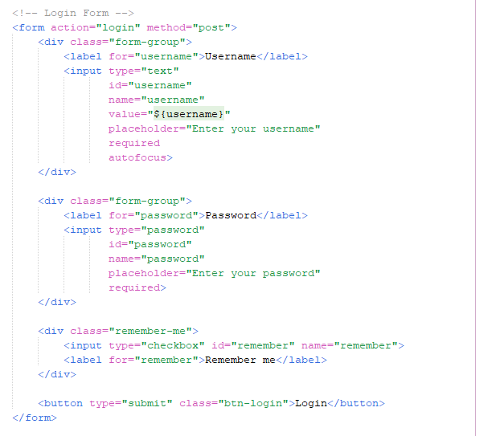

  - Create Dashboard
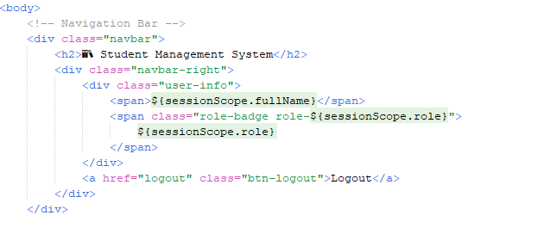
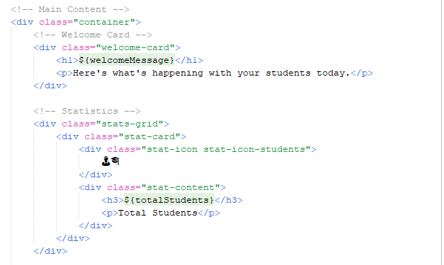
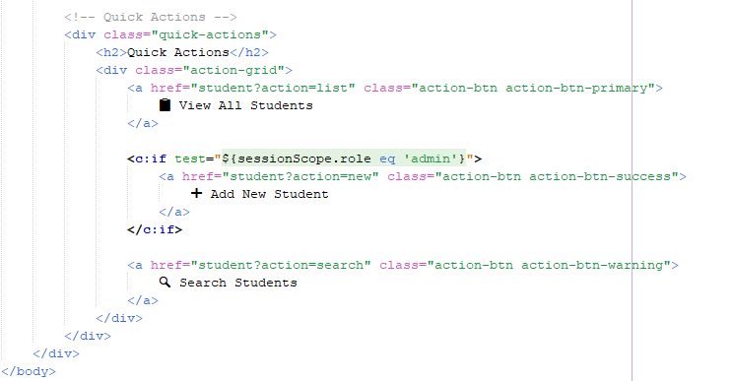

- Explanation and result
  - Database and usermodel
To process to login, we have to create a user table for validating username and password as well as performing identify role for user
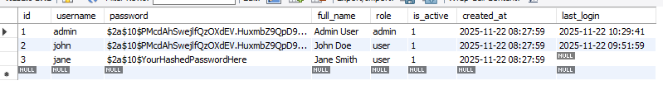
  - User model and DAO
    - Class user.java in model package
Used for defining user object attributes and method
    - Class userDAO.java in DAO package
Used for execute SQL from Controller
  - Login/Logout controller
The controller handles user requests , processes them using DAO and redirect to appropriate views
  - Views and dashboard
Show the User interface in browser based on role

  - Work flow
Login flow :
User opens browser → enters URL
↓
Request sent to server (GET request)
↓
LoginController.java (doGet method) receives request
↓
Controller forwards to login.jsp
↓
login.jsp renders in browser (shows login form)

Submit login form :
User enters username: "john"
User enters password: "123456"
User clicks "Login" button
↓
Form sends POST request to /login
↓
LoginController.java (doPost method) receives request
↓
Controller extracts data:
- String username = request.getParameter("username"); // "john"
- String password = request.getParameter("password"); // "123456"
↓
Controller calls DAO to validate
User enters username: "john"
User enters password: "123456"
Hashed password: BCrypt.hashpw(plainPassword, BCrypt.gensalt())
User clicks "Login" button
↓
Form sends POST request to /login
↓
LoginController.java (doPost method) receives request
↓
Controller extracts data:
- String username = request.getParameter("username"); // "john"
- String password = request.getParameter("password"); //Hashed password

Dashboard flow :
User accesses Dashboard
Browser sends GET request to /dashboard
↓
DashboardController.java (doGet method) receives request
↓
Controller checks if user is logged in:
HttpSession session = request.getSession(false);
User user = (User) session.getAttribute("user");

↓
Session Validate:
Controller gets user from session
↓
Controller checks user role:
String role = user.getRole(); // "admin" or "user"
↓
Controller forwards to appropriate dashboard based on role

Logout flow:
User click logout button :
User clicks "Logout" link/button
↓
Browser sends GET request to /logout
↓
LogoutController.java (doGet method) receives request
↓
Controller gets current session:
HttpSession session = request.getSession(false);
↓
Controller destroys session:
session.invalidate(); // All session data removed
↓
Controller redirects to login page:
response.sendRedirect("login?logout=true");
↓
login.jsp displays with "Logged out successfully" message

  - Result
